JAVA NOTES



**16.www.w3schools.com**

**17.www.javapoint.com**

**18.greaksforgreaks.com**

Our core Java programming tutorial is designed for students and working professionals. Java is an [object-oriented](https://www.javatpoint.com/java-oops-concepts), class-based, concurrent, secured and general-purpose computer-programming language. It is a widely used robust technology.

What is Java

Java is a **programming language** and a **platform**.

Java is a high level, robust, object-oriented and secure programming language.

**Platform**: Any hardware or software environment in which a program runs, is known as a platform. Since Java has a runtime environment (JRE) and API, it is called a platform.

Application

According to Sun, 3 billion devices run Java. There are many devices where Java is currently used. Some of them are as follows:

1. Desktop Applications such as acrobat reader, media player, antivirus, etc.
2. Web Applications such as irctc.co.in, javatpoint.com, etc.
3. Enterprise Applications such as banking applications.
4. Mobile
5. Embedded System
6. Smart Card
7. Robotics
8. Games, etc.

Types of Java Applications

There are mainly 4 types of applications that can be created using Java programming:

1) Standalone Application

Standalone applications are also known as desktop applications or window-based applications. These are traditional software that we need to install on every machine. Examples of standalone application are Media player, antivirus, etc. AWT and Swing are used in Java for creating standalone applications.

2) Web Application

An application that runs on the server side and creates a dynamic page is called a web application. Currently, [Servlet](https://www.javatpoint.com/servlet-tutorial), [JSP](https://www.javatpoint.com/jsp-tutorial), [Struts](https://www.javatpoint.com/struts-2-tutorial), [Spring](https://www.javatpoint.com/spring-tutorial), [Hibernate](https://www.javatpoint.com/hibernate-tutorial), [JSF](https://www.javatpoint.com/jsf-tutorial), etc. technologies are used for creating web applications in Java.

3) Enterprise Application

An application that is distributed in nature, such as banking applications, etc. is called enterprise application. It has advantages of the high-level security, load balancing, and clustering. In Java, [EJB](https://www.javatpoint.com/ejb-tutorial) is used for creating enterprise applications.

4) Mobile Application

An application which is created for mobile devices is called a mobile application. Currently, Android and Java ME are used for creating mobile applications.

**Java Platforms / Editions**

There are 4 platforms or editions of Java:

1) Java SE (Java Standard Edition)

It is a Java programming platform. It includes Java programming APIs such as java.lang, java.io, java.net, java.util, java.sql, java.math etc. It includes core topics like OOPs, [String](https://www.javatpoint.com/java-string), Regex, Exception, Inner classes, Multithreading, I/O Stream, Networking, AWT, Swing, Reflection, Collection, etc.

2) Java EE (Java Enterprise Edition)

It is an enterprise platform which is mainly used to develop web and enterprise applications. It is built on the top of the Java SE platform. It includes topics like Servlet, JSP, Web Services, EJB, [JPA](https://www.javatpoint.com/jpa-tutorial), etc.

3) Java ME (Java Micro Edition)

It is a micro platform which is mainly used to develop mobile applications.

4) JavaFX

It is used to develop rich internet applications. It uses a light-weight user interface API.

Prerequisite

To learn Java, you must have the basic knowledge of C/C++ programming language.





|  |  |  |  |
| --- | --- | --- | --- |
| java SE 8 (LTS) | March 2014 | **January 2019 for Oracle (commercial)** December 2020 for Oracle (personal use) At least September 2023 for AdoptOpenJDK | March 2025 |
| Java SE 9 | September 2017 | March 2018 for OpenJDK | N/A |
| Java SE 10 | March 2018 | September 2018 for OpenJDK | N/A |
| Java SE 11 (LTS) | September 2018 | At least September 2022 for AdoptOpenJDK | September 2026 |
| **Java SE 12** | March 2019 | September 2019 for OpenJDK | N/A |

























|  |  |  |  |  |  |  |  |  |  |  |  |  |  |  |  |  |  |  |
| --- | --- | --- | --- | --- | --- | --- | --- | --- | --- | --- | --- | --- | --- | --- | --- | --- | --- | --- |
| [**next →**](https://www.javatpoint.com/difference-between-jdk-jre-and-jvm)[**← prev**](https://www.javatpoint.com/internal-details-of-hello-java-program) **How to set path in Java** The path is required to be set for using tools such as javac, java, etc.  If you are saving the Java source file inside the JDK/bin directory, the path is not required to be set because all the tools will be available in the current directory.  However, if you have your Java file outside the JDK/bin folder, it is necessary to set the path of JDK.  There are two ways to set the path in Java:   1. Temporary 2. Permanent  **1) How to set the Temporary Path of JDK in Windows** To set the temporary path of JDK, you need to follow the following steps:   * Open the command prompt * Copy the path of the JDK/bin directory * Write in command prompt: set path=copied\_path  **For Example:** set path=C:\Program Files\Java\jdk1.6.0\_23\bin  Let's see it in the figure given below:  How to set the path in Java **2) How to set Permanent Path of JDK in Windows** For setting the permanent path of JDK, you need to follow these steps:   * Go to MyComputer properties -> advanced tab -> environment variables -> new tab of user variable -> write path in variable name -> write path of bin folder in variable value -> ok -> ok -> ok  **For Example:**  |  | | --- | | **1) Go to MyComputer properties** | | how to set path in java | | **2) Click on the advanced tab** | | how to set path in java | | **3) Click on environment variables** | | how to set path in java | | **4) Click on the new tab of user variables** | | how to set path in java | | **5) Write the path in the variable name** | | how to set path in java | | **6) Copy the path of bin folder** | | how to set path in java | | **7) Paste path of bin folder in the variable value** | | how to set path in java | | **8) Click on ok button** | | how to set path in java | | **9) Click on ok button** | | how to set path in java |   Now your permanent path is set. You can now execute any program of java from any drive. |

### **Creating Hello World Example**

Let's create the hello java program:

1. **class** Simple{
2. **public** **static** **void** main(String args[]){
3. System.out.println("Hello Java");
4. }
5. }

save this file as Simple.java

|  |  |
| --- | --- |
| **To compile:** | javac Simple.java |
| **To execute:** | java Simple |

**Output:**Hello Java

**Compilation Flow:**

When we compile Java program using javac tool, java compiler converts the source code into byte code.

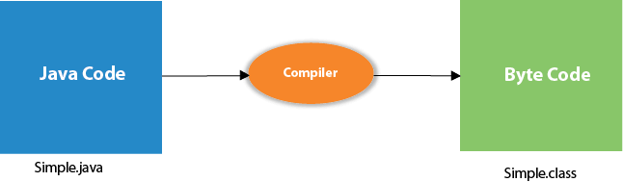

## **Parameters used in First Java Program**

Let's see what is the meaning of class, public, static, void, main, String[], System.out.println().

* **class** keyword is used to declare a class in java.
* **public** keyword is an access modifier which represents visibility. It means it is visible to all.
* **static** is a keyword. If we declare any method as static, it is known as the static method. The core advantage of the static method is that there is no need to create an object to invoke the static method. The main method is executed by the JVM, so it doesn't require to create an object to invoke the main method. So it saves memory.
* **void** is the return type of the method. It means it doesn't return any value.
* **main** represents the starting point of the program.
* **String[] args** is used for command line argument. We will learn it later.
* **System.out.println()** is used to print statement. Here, System is a class, out is the object of PrintStream class, println() is the method of PrintStream class. We will learn about the internal working of System.out.println statement later.







## **How many ways can we write a Java program**

There are many ways to write a Java program. The modifications that can be done in a Java program are given below:

**1) By changing the sequence of the modifiers, method prototype is not changed in Java.**

Let's see the simple code of the main method.

1. **static** **public** **void** main(String args[])

**2) The subscript notation in Java array can be used after type, before the variable or after the variable.**

Let's see the different codes to write the main method.

1. **public** **static** **void** main(String[] args)
2. **public** **static** **void** main(String []args)
3. **public** **static** **void** main(String args[])

**3) You can provide var-args support to the main method by passing 3 ellipses (dots)**

Let's see the simple code of using var-args in the main method. We will learn about var-args later in Java New Features chapter.

1. **public** **static** **void** main(String... args)

**4) Having a semicolon at the end of class is optional in Java.**

Let's see the simple code.

1. **class** A{
2. **static** **public** **void** main(String... args){
3. System.out.println("hello java4");
4. }
5. };

## **Valid java main method signature**

1. **public** **static** **void** main(String[] args)
2. **public** **static** **void** main(String []args)
3. **public** **static** **void** main(String args[])
4. **public** **static** **void** main(String... args)
5. **static** **public** **void** main(String[] args)
6. **public** **static** **final** **void** main(String[] args)
7. **final** **public** **static** **void** main(String[] args)
8. **final** **strictfp** **public** **static** **void** main(String[] args)





# **Java Comments**

Comments can be used to explain Java code, and to make it more readable. It can also be used to prevent execution when testing alternative code.

Single-line comments start with two forward slashes (//).

Any text between // and the end of the line is ignored by Java (will not be executed).

This example uses a single-line comment before a line of code:

### **Example**

// This is a comment  
System.out.println("Hello World");

This example uses a single-line comment at the end of a line of code:

### **Example**

System.out.println("Hello World"); // This is a comment

## **Java Multi-line Comments**

Multi-line comments start with /\* and ends with \*/.

Any text between /\* and \*/ will be ignored by Java.

This example uses a multi-line comment (a comment block) to explain the code:

### **Example**

/\* The code below will print the words Hello World  
to the screen, and it is amazing \*/  
System.out.println("Hello World");



# **Java Variables**

A variable is a container which holds the value while the java program is executed. A variable is assigned with a datatype.

Variable is a name of memory location. There are three types of variables in java: local, instance and static.

There are two types of data types in java: primitive and non-primitive.

## **Variable**

**Variable** is name of reserved area allocated in memory. In other words, it is a name of memory location. It is a combination of "vary + able" that means its value can be changed.

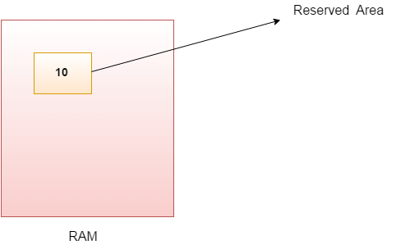

1. **int** data=50;//Here data is variable

Here is a list of all primitives in Java:

* byte (number, 1 byte)
* short (number, 2 bytes)
* int (number, 4 bytes)
* long (number, 8 bytes)
* float (float number, 4 bytes)
* double (float number, 8 bytes)
* char (a character, 2 bytes)
* boolean (true or false, 1 byte)

Java is a strong typed language, which means variables need to be defined before we use them.

### **Numbers**

To declare and assign a number use the following syntax:

int myNumber;

myNumber = 5;

Or you can combine them:

int myNumber = 5;

To define a double floating point number, use the following syntax:

double d = 4.5;

d = 3.0;

## **Java Identifiers**

All Java **variables** must be **identified** with **unique names**.

These unique names are called **identifiers**.

Identifiers can be short names (like x and y) or more descriptive names (age, sum, totalVolume).

The general rules for constructing names for variables (unique identifiers) are:

* Names can contain letters, digits, underscores, and dollar signs
* Names should begin with a letter
* Names can also begin with $ and \_ (but we will not use it in this tutorial)
* Names are case sensitive ("myVar" and "myvar" are different variables)
* Names should start with a lowercase letter and it cannot contain whitespace
* Reserved words (like Java keywords, such as int or String) cannot be used as names

**Identifiers:-**

any name in the java program like variable name,class name,method name,interface name is called identifier.

class Test Test-------→identifier

{

void add() add-------→identifier

{

int a=10; a----------→identifiers

int b=20; b----------→identifiers

}

};

**Rules to declare identifiers:-**

1. the java identifiers should not start with numbers,it may start with alphabet symbol and underscore symbol and dollar symbol.

a. Int abc=10;-----→valied

b. Int 2abc=20;----→not valied

c. Int \_abc=30;----→valied

d. Int $abc=40;----→valied

e. Int @abc=50;---→not valied

2. The identifier will not contains symbols like

+ , - , . , @ , # , \*………………….

3. The identifier should not duplicated.

class Test

{

void add()

{

int a=10;

int a=20; the identifier should not be duplicated.

}

};

4. In the java applications it is possible to declare all the predefined class names and predefined interfaces names as a identifier. But it is not recamanded to use.

class Test

{

public static void main(String[] args)

{

int String=10; //predefind String class

int Serializable=20; //predified Seriaiable class

float Exception=10.2f; //predefined Exception class

System.out.println(String);

System.out.println(Serializable);

System.out.println(Exception);

}

};

# **Data Types in Java**



Data types specify the different sizes and values that can be stored in the variable. There are two types of data types in Java:

1. **Primitive data types:** The primitive data types include boolean, char, byte, short, int, long, float and double.
2. **Non-primitive data types:** The non-primitive data types include Classes, Interfaces, and Arrays.

## **Java Primitive Data Types**

In Java language, primitive data types are the building blocks of data manipulation. These are the most basic data types available in Java language.

Java is a statically-typed programming language. It means, all variables must be declared before its use. That is why we need to declare variable's type and name.

There are 8 types of primitive data types:

* boolean data type
* byte data type
* char data type
* short data type
* int data type
* long data type
* float data type
* double data type

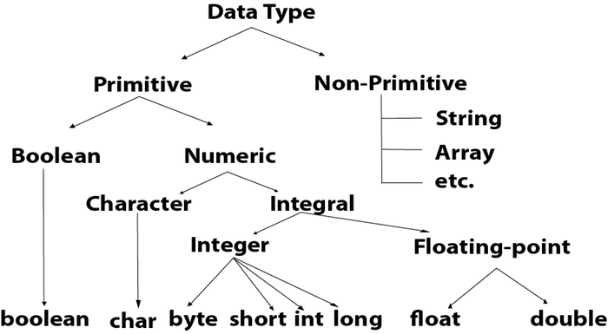



## **Numbers**

Primitive number types are divided into two groups:

**Integer types** stores whole numbers, positive or negative (such as 123 or -456), without decimals. Valid types are byte, short, int and long. Which type you should use, depends on the numeric value.

**Floating point types** represents numbers with a fractional part, containing one or more decimals. There are two types: float and double.

Even though there are many numeric types in Java, the most used for numbers are int (for whole numbers) and double (for floating point numbers). However, we will describe them all as you continue to read.

## **Integer Types**

### **Byte**

The byte data type can store whole numbers from -128 to 127. This can be used instead of int or other integer types to save memory when you are certain that the value will be within -128 and 127:

### **Example**

byte myNum = 100;  
System.out.println(myNum);

[Run example »](https://www.w3schools.com/java/showjava.asp?filename=demo_type_byte)

### **Short**

The short data type can store whole numbers from -32768 to 32767:

### **Example**

short myNum = 5000;  
System.out.println(myNum);

[Run example »](https://www.w3schools.com/java/showjava.asp?filename=demo_type_short)

### **Int**

The int data type can store whole numbers from -2147483648 to 2147483647. In general, and in our tutorial, the int data type is the preferred data type when we create variables with a numeric value.

### **Example**

int myNum = 100000;  
System.out.println(myNum);

[Run example »](https://www.w3schools.com/java/showjava.asp?filename=demo_type_int)

### **Long**

The long data type can store whole numbers from -9223372036854775808 to 9223372036854775807. This is used when int is not large enough to store the value. Note that you should end the value with an "L":

### **Example**

long myNum = 15000000000L;  
System.out.println(myNum);

[Run example »](https://www.w3schools.com/java/showjava.asp?filename=demo_type_long)

## **Floating Point Types**

You should use a floating point type whenever you need a number with a decimal, such as 9.99 or 3.14515.

### **Float**

The float data type can store fractional numbers from 3.4e−038 to 3.4e+038. Note that you should end the value with an "f":

### **Example**

float myNum = 5.75f;  
System.out.println(myNum);

[Run example »](https://www.w3schools.com/java/showjava.asp?filename=demo_type_float)

### **Double**

The double data type can store fractional numbers from 1.7e−308 to 1.7e+038. Note that you should end the value with a "d":

### **Example**

double myNum = 19.99d;  
System.out.println(myNum);

[Run example »](https://www.w3schools.com/java/showjava.asp?filename=demo_type_double)

Use float or double?

The **precision** of a floating point value indicates how many digits the value can have after the decimal point. The precision of float is only six or seven decimal digits, while double variables have a precision of about 15 digits. Therefore it is safer to use double for most calculations.

### **Scientific Numbers**

A floating point number can also be a scientific number with an "e" to indicate the power of 10:

### **Example**

float f1 = 35e3f;  
double d1 = 12E4d;  
System.out.println(f1);  
System.out.println(d1);

[Run example »](https://www.w3schools.com/java/showjava.asp?filename=demo_type_scientific)

## **Booleans**

A boolean data type is declared with the boolean keyword and can only take the values true or false:

### **Example**

boolean isJavaFun = true;  
boolean isFishTasty = false;  
System.out.println(isJavaFun);     // Outputs true  
System.out.println(isFishTasty);   // Outputs false

[Run example »](https://www.w3schools.com/java/showjava.asp?filename=demo_booleans)

Boolean values are mostly used for conditional testing, which you will learn more about in a later chapter.

## **Characters**

The char data type is used to store a **single** character. The character must be surrounded by single quotes, like 'A' or 'c':

### **Example**

char myGrade = 'B';  
System.out.println(myGrade);

[Run example »](https://www.w3schools.com/java/showjava.asp?filename=demo_type_char)

Alternatively, you can use ASCII values to display certain characters:

### **Example**

char a = 65, b = 66, c = 67;  
System.out.println(a);  
System.out.println(b);  
System.out.println(c);

**Tip:** A list of all ASCII values can be found in our [ASCII Table Reference](https://www.w3schools.com/charsets/ref_html_ascii.asp).

## **Strings**

The String data type is used to store a sequence of characters (text). String values must be surrounded by double quotes:

### **Example**

String greeting = "Hello World";  
System.out.println(greeting);

The String type is so much used and integrated in Java, that some call it "the special **ninth** type".

A String in Java is actually a **non-primitive** data type, because it refers to an object. The String object has methods that is used to perform certain operations on strings. **Don't worry if you don't understand the term "object" just yet**. We will learn more about strings and objects in a later chapter.

## **Non-Primitive Data Types**

Non-primitive data types are called **reference types** because they refer to objects.

The main difference between **primitive** and **non-primitive** data types are:

* Primitive types are predefined (already defined) in Java. Non-primitive types are created by the programmer and is not defined by Java (except for String).
* Non-primitive types can be used to call methods to perform certain operations, while primitive types cannot.
* A primitive type has always a value, while non-primitive types can be null.
* A primitive type starts with a lowercase letter, while non-primitive types starts with an uppercase letter.
* The size of a primitive type depends on the data type, while non-primitive types have all the same size.

## **Java Type Casting**

Type casting is when you assign a value of one primitive data type to another type.

In Java, there are two types of casting:

* **Widening Casting** (automatically) - converting a smaller type to a larger type size  
  byte -> short -> char -> int -> long -> float -> double
* **Narrowing Casting** (manually) - converting a larger type to a smaller size type  
  double -> float -> long -> int -> char -> short -> byte

## **Widening Casting**

Widening casting is done automatically when passing a smaller size type to a larger size type:

### **Example**

public class MyClass {  
  public static void main(String[] args) {  
    int myInt = 9;  
    double myDouble = myInt; // Automatic casting: int to double  
  
    System.out.println(myInt);      // Outputs 9  
    System.out.println(myDouble);   // Outputs 9.0  
  }  
}

## **Narrowing Casting**

Narrowing casting must be done manually by placing the type in parantheses in front of the value:

### **Example**

public class MyClass {  
  public static void main(String[] args) {  
    double myDouble = 9.78;  
    int myInt = (int) myDouble; // Manual casting: double to int  
  
    System.out.println(myDouble);   // Outputs 9.78  
    System.out.println(myInt);      // Outputs 9  
  }  
}

# **Java Operators**

## **Java Operators**

Operators are used to perform operations on variables and values.

The value is called an operand, while the operation (to be performed between the two operands) is defined by an **operator**:

|  |  |  |
| --- | --- | --- |
| **Operand** | **Operator** | **Operand** |
| 100 | + | 50 |

In the example below, the numbers 100 and 50 are **operands**, and the + sign is an **operator**:

### **Example**

int x = 100 + 50;

Although the + operator is often used to add together two values, like in the example above, it can also be used to add together a variable and a value, or a variable and another variable:

### **Example**

int sum1 = 100 + 50;        // 150 (100 + 50)  
int sum2 = sum1 + 250;      // 400 (150 + 250)  
int sum3 = sum2 + sum2;     // 800 (400 + 400)

Java divides the operators into the following groups:

* Arithmetic operators
* Unary operators
* Assignment operators
* Comparison operators
* Logical operators
* Bitwise operators
* Conditional or ternary operator

## **1)Arithmetic Operators**

Arithmetic operators are used to perform common mathematical operations.

|  |  |  |  |
| --- | --- | --- | --- |
| **Operator** | **Name** | **Description** | **Example** |
| + | Addition | Adds together two values | x + y |
| - | Subtraction | Subtracts one value from another | x - y |
| \* | Multiplication | Multiplies two values | x \* y |
| / | Division | Divides one value from another | x / y |
| % | Modulus | Returns the division remainder | x % y |

Ex: public class MyClass {

public static void main(String[] args) {

int x = 5;

int y = 2;

System.out.println(x % y);

}

}

Ex:2

class ArithmeticOperator {

public static void main(String[] args) {

double number1 = 12.5, number2 = 3.5, result;

// Using addition operator

result = number1 + number2;

System.out.println("number1 + number2 = " + result);

// Using subtraction operator

result = number1 - number2;

System.out.println("number1 - number2 = " + result);

// Using multiplication operator

result = number1 \* number2;

System.out.println("number1 \* number2 = " + result);

// Using division operator

result = number1 / number2;

System.out.println("number1 / number2 = " + result);

// Using remainder operator

result = number1 % number2;

System.out.println("number1 % number2 = " + result);

}

}

2)unary operators:++ or --

### **Java Unary Operator**

the unary operators require only one operand; they perform various operations such as incrementing/decrementing a value by one, negating an expression, or inverting the value of a boolean.

|  |  |
| --- | --- |
| **Operator** | **Description** |
| + | Unary plus operator; indicates positive value (numbers are positive without this, however) |
| - | Unary minus operator; negates an expression |
| ++ | Increment operator; increments a value by 1 |
| -- | Decrement operator; decrements a value by 1 |
| ! | Logical complement operator; inverts the value of a boolean |

class UnaryDemo {

public static void main(String[] args) {

int result = +1;

// result is now 1

System.out.println(result);

result--;

// result is now 0

System.out.println(result);

result++;

// result is now 1

System.out.println(result);

result = -result;

// result is now -1

System.out.println(result);

boolean success = false;

// false

System.out.println(success);

// true

System.out.println(!success);

}

}

The increment/decrement operators can be applied before (prefix) or after (postfix) the operand. The code result++; and ++result; will both end in result being incremented by one. The only difference is that the prefix version (++result) evaluates to the incremented value, whereas the postfix version (result++) evaluates to the original value. If you are just performing a simple increment/decrement, it doesn't really matter which version you choose. But if you use this operator in part of a larger expression, the one that you choose may make a significant difference.

The following program, [PrePostDemo](https://docs.oracle.com/javase/tutorial/java/nutsandbolts/examples/PrePostDemo.java" \t "_blank), illustrates the prefix/postfix unary increment operator:

class PrePostDemo {

public static void main(String[] args){

int i = 3;

i++;

// prints 4

System.out.println(i);

++i;

// prints 5

System.out.println(i);

// prints 6

System.out.println(++i);

// prints 6

System.out.println(i++);

// prints 7

System.out.println(i);

}

}

The Java unary operators require only one operand. Unary operators are used to perform various operations i.e.:

incrementing/decrementing a value by one

Ex1:

public class MyClass {

public static void main(String[] args) {

int x = 5;

++x;

System.out.println(x);

}

}

Ex2:

public class MyClass {

public static void main(String[] args) {

int x = 5;

--x;

System.out.println(x);

}

}

## **3)Java Assignment Operators**

Assignment operators are used to assign values to variables.

In the example below, we use the **assignment** operator (=) to assign the value **10** to a variable called **x**:

### **Example**

int x = 10;

The **addition assignment** operator (+=) adds a value to a variable:

### **Example**

int x = 10;  
x += 5;

A list of all assignment operators:

|  |  |  |
| --- | --- | --- |
| **Operator** | **Example** | **Same As** |
| = | x = 5 | x = 5 |
| += | x += 3 | x = x + 3 |
| -= | x -= 3 | x = x - 3 |
| \*= | x \*= 3 | x = x \* 3 |
| /= | x /= 3 | x = x / 3 |
| %= | x %= 3 | x = x % 3 |
| &= | x &= 3 | x = x & 3 |
| |= | x |= 3 | x = x | 3 |
| ^= | x ^= 3 | x = x ^ 3 |
| >>= | x >>= 3 | x = x >> 3 |
| <<= | x <<= 3 | x = x << 3 |

Ex 1: public class MyClass {

public static void main(String[] args) {

int x = 10;

x += 5;

System.out.println(x);

}

}

## **ex 2:**

public class Test {

public static void main(String args[]) {

int a = 10;

int b = 20;

int c = 0;

c = a + b;

System.out.println("c = a + b = " + c );

c += a ;

System.out.println("c += a = " + c );

c -= a ;

System.out.println("c -= a = " + c );

c \*= a ;

System.out.println("c \*= a = " + c );

a = 10;

c = 15;

c /= a ;

System.out.println("c /= a = " + c );

a = 10;

c = 15;

c %= a ;

System.out.println("c %= a = " + c );

c <<= 2 ;

System.out.println("c <<= 2 = " + c );

c >>= 2 ;

System.out.println("c >>= 2 = " + c );

c >>= 2 ;

System.out.println("c >>= 2 = " + c );

c &= a ;

System.out.println("c &= a = " + c );

c ^= a ;

System.out.println("c ^= a = " + c );

c |= a ;

System.out.println("c |= a = " + c );

}

}

This will produce the following result −

## **Output**

c = a + b = 30

c += a = 40

c -= a = 30

c \*= a = 300

c /= a = 1

c %= a = 5

c <<= 2 = 20

c >>= 2 = 5

c >>= 2 = 1

c &= a = 0

c ^= a = 10

c |= a = 10

## **4) Relational operators**

Comparison operators are used to compare two values:

|  |  |  |
| --- | --- | --- |
| **Operator** | **Name** | **Example** |
| == | Equal to | x == y |
| != | Not equal | x != y |
| > | Greater than | x > y |
| < | Less than | x < y |
| >= | Greater than or equal to | x >= y |
| <= | Less than or equal to | x <= y |

EX:

Class ComparisonDemo {

public static void main(String[] args){

int value1 = 1;

int value2 = 2;

if(value1 == value2)

System.out.println("value1 == value2");

if(value1 != value2)

System.out.println("value1 != value2");

if(value1 > value2)

System.out.println("value1 > value2");

if(value1 < value2)

System.out.println("value1 < value2");

if(value1 <= value2)

System.out.println("value1 <= value2");

}

}

Output:

value1 != value2

value1 < value2

value1 <= value2

## **4)Java Logical Operators**

Logical operators are used to determine the logic between variables or values:

|  |  |  |  |
| --- | --- | --- | --- |
| **Operator** | **Name** | **Description** | **Example** |
| && | Logical and | Returns true if both statements are true | x < 5 &&  x < 10 |
| || | Logical or | Returns true if one of the statements is true | x < 5 || x < 4 |
| ! | Logical not | Reverse the result, returns false if the result is true | !(x < 5 && x < 10) |

Example:

public class LogicalOperatorDemo1

{

public static void main(String args[])

{

//1. Logical And operator

System. out .println( "\*\*\*\*\*\*\*\*\*\*\*Logical AND Operator Examples\*\*\*\*\*\*\*\*\*\*\*\*\*\*" );

int value1 = 10;

int value2 = 20;

int value3= 30;

boolean result1 = value2>value1 && value2<value3;

System. out .println( "value2>value1 && value2<value3 - result1 is " +result1);

boolean result2 = value2<value1 && value2<value3;

System. out .println( "value2<value1 && value2<value3 - result2 is " +result2);

boolean result3 = value2>value1 && value2>value3;

System. out .println( "value2>value1 && value2>value3 - result3 is " +result3);

boolean result4 = value2<value1 && value2>value3;

System. out .println( "value2<value1 && value2>value3 - result4 is " +result4);

//2. Logical OR operator

System. out .println( "\*\*\*\*\*\*\*\*\*\*\*Logical OR Operator Examples\*\*\*\*\*\*\*\*\*\*\*\*\*\*" );

result1 = value2>value1 || value2<value3;

System. out .println( "value2>value1 || value2<value3 - result1 is " +result1);

result2 = value2<value1 || value2<value3;

System. out .println( "value2<value1 || value2<value3 - result2 is " +result2);

result3 = value2>value1 || value2>value3;

System. out .println( "value2>value1 || value2>value3 - result3 is " +result3);

result4 = value2<value1 || value2>value3;

System. out .println( "value2<value1 || value2>value3 - result4 is " +result4);

//3.Logical Not Operator

System. out .println( "\*\*\*\*\*\*\*\*\*\*\*Logical Not Operator Examples\*\*\*\*\*\*\*\*\*\*\*\*\*\*" );

boolean flag = false ;

boolean newFlag = ! flag;

System. out .println( "flag : " +flag);

System. out .println( "newFlag : " +newFlag);

int test1 = 10;

int test2 = 15;

int test3 = 20;

boolean testResult1 = test1<test2;

boolean testResult2 = !(test1<test2);

System. out .println( "testResult1 : " +testResult1);

System. out .println( "testResult2 : " +testResult2);

boolean testResult3 = test1<test2 && test2<test3;

boolean testResult4 = !(test1<test2 && test2<test3);

System. out .println( "testResult3 : " +testResult3);

System. out .println( "testResult4 : " +testResult4);

}

}

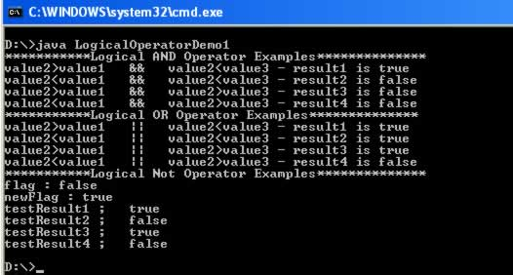

Bitwise Operators

## **5)The Bitwise Operators**

Java defines several bitwise operators, which can be applied to the integer types, long, int, short, char, and byte.

Bitwise operator works on bits and performs bit-by-bit operation. Assume if a = 60 and b = 13; now in binary format they will be as follows −

a = 0011 1100

b = 0000 1101

-----------------

a&b = 0000 1100

a|b = 0011 1101

a^b = 0011 0001

~a  = 1100 0011

The following table lists the bitwise operators −

Assume integer variable A holds 60 and variable B holds 13 then −

[Show Examples](https://www.tutorialspoint.com/java/java_bitwise_operators_examples.htm)

|  |  |  |
| --- | --- | --- |
| **Operator** | **Description** | **Example** |
| & (bitwise and) | Binary AND Operator copies a bit to the result if it exists in both operands. | (A & B) will give 12 which is 0000 1100 |
| | (bitwise or) | Binary OR Operator copies a bit if it exists in either operand. | (A | B) will give 61 which is 0011 1101 |
| ^ (bitwise XOR) | Binary XOR Operator copies the bit if it is set in one operand but not both. | (A ^ B) will give 49 which is 0011 0001 |
| ~ (bitwise compliment) | Binary Ones Complement Operator is unary and has the effect of 'flipping' bits. | (~A ) will give -61 which is 1100 0011 in 2's complement form due to a signed binary number. |
| << (left shift) | Binary Left Shift Operator. The left operands value is moved left by the number of bits specified by the right operand. | A << 2 will give 240 which is 1111 0000 |
| >> (right shift) | Binary Right Shift Operator. The left operands value is moved right by the number of bits specified by the right operand. | A >> 2 will give 15 which is 1111 |
| >>> (zero fill right shift) | Shift right zero fill operator. The left operands value is moved right by the number of bits specified by the right operand and shifted values are filled up with zeros. | A >>>2 will give 15 which is 0000 1111 |

### 6) **Conditional Operator ( ? : )**

Conditional operator is also known as the **ternary operator**. This operator consists of three operands and is used to evaluate Boolean expressions. The goal of the operator is to decide, which value should be assigned to the variable. The operator is written as −

variable x = (expression) ? value if true : value if false

Following is an example −

**Example**

public class Test {

public static void main(String args[]) {

int a, b;

a = 10;

b = (a == 1) ? 20: 30;

System.out.println( "Value of b is : " + b );

b = (a == 10) ? 20: 30;

System.out.println( "Value of b is : " + b );

}

}

This will produce the following result −

**Output**

Value of b is : 30

Value of b is : 20

## **java Strings**

Strings are used for storing text.

A String variable contains a collection of characters surrounded by double quotes:

Ex:

Create a variable of type String and assign it a value:

String greeting = "Hello";

## **String Length**

A String in Java is actually an object, which contain methods that can perform certain operations on strings. For example, the length of a string can be found with the length() method:

1)length()---find length

2) toUpperCase() and toLowerCase():==change the case

3) indexOf()--**Finding a String in a String**

**4)** concat()

5) **Escape character**

|  |  |  |
| --- | --- | --- |
| **Escape character** | **Result** | **Description** |
| \' | ' | Single quote |
| \" | " | Double quote |
| \\ | \ | Backslash |

6) escape sequences

|  |  |
| --- | --- |
| **Code** | **Result** |
| \n | New Line |
| \r | Carriage Return |
| \t | Tab |
| \b | Backspace |
| \f | Form Feed |

Example:

public class MyClass {

public static void main(String[] args) {

String txt = "ABCDEFGHIJKLMNOPQRSTUVWXYZ";

System.out.println("The length of the txt string is: " + txt.length());

String txt = "Hello World";  
System.out.println(txt.toUpperCase());   // Outputs "HELLO WORLD"  
System.out.println(txt.toLowerCase());   // Outputs "hello world"

String txt = "Please locate where 'locate' occurs!";  
System.out.println(txt.indexOf("locate")); // Outputs 7

String firstName = "John ";  
String lastName = "Doe";  
System.out.println(firstName.concat(lastName));

String txt = "It\'s alright.";

String txt = "The character \\ is called backslash.";

}

}

## Control Statements OR DECISION MAKING STATEMENTS

1) if statement

2)if-else statement

3)if-else-if –else adder

4)nested if statement

5)switch statement

1) Java has the following conditional statements:

* Use if to specify a block of code to be executed, if a specified condition is true
* Use else to specify a block of code to be executed, if the same condition is false
* Use else if to specify a new condition to test, if the first condition is false
* Use switch to specify many alternative blocks of code to be executed

## **java if Statement**

The Java if statement tests the condition. It executes the if block if condition is true.

**Syntax:**

**if**(condition){

//code to be executed

}

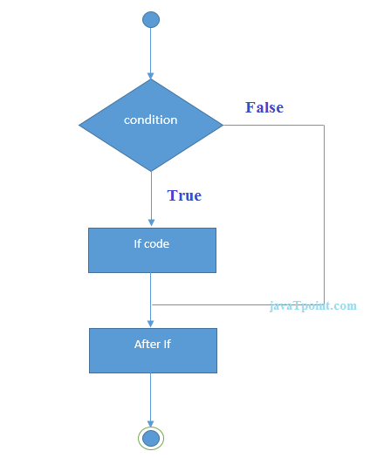

**Example:**

//Java Program to demonstate the use of if statement.

**public** **class** IfExample {

**public** **static** **void** main(String[] args) {

    //defining an 'age' variable

**int** age=20;

    //checking the age

**if**(age>18){

        System.out.print("Age is greater than 18");

    }

}

}

Output:

Age is greater than 18

## **Java if-else Statement**

The Java if-else statement also tests the condition. It executes the if block if condition is true otherwise else block is executed.

**Syntax:**

**if**(condition){

//code if condition is true

}**else**{

//code if condition is false

}

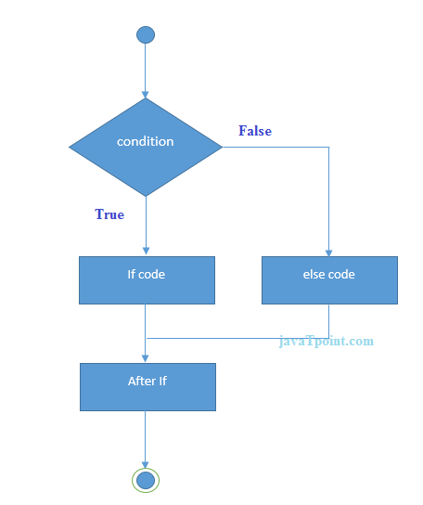

**Example:**

//A Java Program to demonstrate the use of if-else statement.

//It is a program of odd and even number.

**public** **class** IfElseExample {

**public** **static** **void** main(String[] args) {

    //defining a variable

**int** number=13;

    //Check if the number is divisible by 2 or not

**if**(number%2==0){

        System.out.println("even number");

    }**else**{

        System.out.println("odd number");

    }

}

}

Output:

odd number

**Leap Year Example:**

A year is leap, if it is divisible by 4 and 400. But, not by 100.

**public** **class** LeapYearExample {

**public** **static** **void** main(String[] args) {

**int** year=2020;

**if**(((year % 4 ==0) && (year % 100 !=0)) || (year % 400==0)){

        System.out.println("LEAP YEAR");

    }

**else**{

        System.out.println("COMMON YEAR");

    }

}

}

Output:

LEAP YEAR

## **Java if-else-if ladder Statement**

The if-else-if ladder statement executes one condition from multiple statements.

**Syntax:**

**if**(condition1){

//code to be executed if condition1 is true

}**else** **if**(condition2){

//code to be executed if condition2 is true

}

**else** **if**(condition3){

//code to be executed if condition3 is true

}

...

**else**{

//code to be executed if all the conditions are false

}

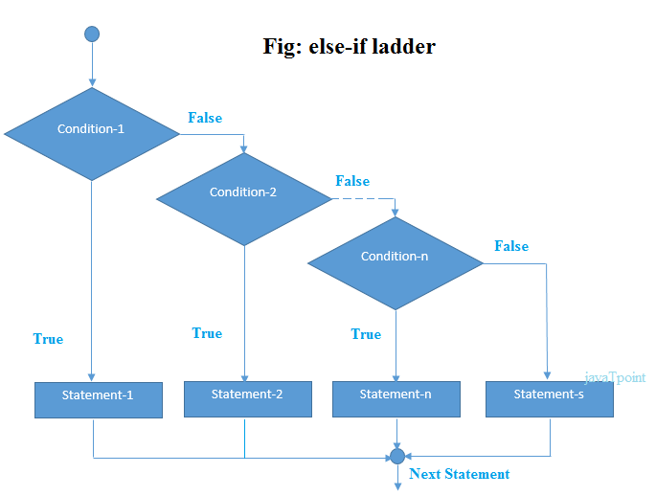

**Example:**

//Java Program to demonstrate the use of If else-if ladder.

//It is a program of grading system for fail, D grade, C grade, B grade, A grade and A+.

**public** **class** IfElseIfExample {

**public** **static** **void** main(String[] args) {

**int** marks=65;

**if**(marks<50){

        System.out.println("fail");

    }

**else** **if**(marks>=50 && marks<60){

        System.out.println("D grade");

    }

**else** **if**(marks>=60 && marks<70){

        System.out.println("C grade");

    }

**else** **if**(marks>=70 && marks<80){

        System.out.println("B grade");

    }

**else** **if**(marks>=80 && marks<90){

        System.out.println("A grade");

    }**else** **if**(marks>=90 && marks<100){

        System.out.println("A+ grade");

    }**else**{

        System.out.println("Invalid!");

    }

}

}

Output:

C grade

**Program to check POSITIVE, NEGATIVE or ZERO:**

**public** **class** PositiveNegativeExample {

**public** **static** **void** main(String[] args) {

**int** number=-13;

**if**(number>0){

    System.out.println("POSITIVE");

    }**else** **if**(number<0){

    System.out.println("NEGATIVE");

    }**else**{

    System.out.println("ZERO");

   }

}

}

Output:

NEGATIVE

## **Java Nested if statement**

The nested if statement represents the if block within another if block. Here, the inner if block condition executes only when outer if block condition is true.

**Syntax:**

**if**(condition){

     //code to be executed

**if**(condition){

             //code to be executed

    }

}

**if**(condition){

     //code to be executed

**if**(condition){

             //code to be executed

    }

}

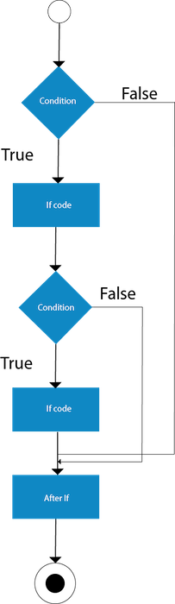

**Example:**

//Java Program to demonstrate the use of Nested If Statement.

**public** **class** JavaNestedIfExample {

**public** **static** **void** main(String[] args) {

    //Creating two variables for age and weight

**int** age=20;

**int** weight=80;

    //applying condition on age and weight

**if**(age>=18){

**if**(weight>50){

            System.out.println("You are eligible to donate blood");

        }

    }

}}

Output:

You are eligible to donate blood

**Example 2:**

//Java Program to demonstrate the use of Nested If Statement.

**public** **class** JavaNestedIfExample2 {

**public** **static** **void** main(String[] args) {

    //Creating two variables for age and weight

**int** age=25;

**int** weight=48;

    //applying condition on age and weight

**if**(age>=18){

**if**(weight>50){

            System.out.println("You are eligible to donate blood");

        } **else**{

            System.out.println("You are not eligible to donate blood");

        }

    } **else**{

      System.out.println("Age must be greater than 18");

    }

}  }

Output:

You are not eligible to donate blood



## **Java Switch Statements**

Use the switch statement to select one of many code blocks to be executed.

### **Syntax**

switch(expression) {  
  case x:  
    *// code block*  
    break;  
  case y:  
    *// code block*  
    break;  
  default:  
    *// code block*  
}

The basic format of the switch statement is:

Syntax:

switch(variable)

{

case 1:

//execute your code

break;

case n:

//execute your code

break;

default:

//execute your code

break;

}

After the end of each block it is necessary to insert a break statement because if the programmers do not use the break statement, all consecutive blocks of codes will get executed from each case onwards after matching the case block.

### **Example of a Java Program to Demonstrate Switch Statement**

Example:

public class Sample {

public static void main(String args[]) {

int a = 5;

switch (a) {

case 1:

System.out.println("You chose One");

break;

case 2:

System.out.println("You chose Two");

break;

case 3:

System.out.println("You chose Three");

break;

case 4:

System.out.println("You chose Four");

break;

case 5:

System.out.println("You chose Five");

break;

default:

System.out.println("Invalid Choice. Enter a no between 1 and 5");

break;

}

}

}

Program Output:

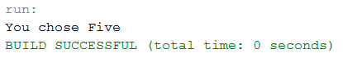  
When none of the cases is evaluated to true, the default case will be executed, and break statement is not required for default statement.

**JAVA LOOP STATEMENTS:**

**LOOP**: A computer is the most suitable machine to perform repetitive tasks and can tirelessly do a task tens of thousands of times. Every programming language has the feature to instruct to do such repetitive tasks with the help of certain form of statements. The process of repeatedly executing a collection of statement is called looping. The statements get executed many numbers of times based on the condition. But if the condition is given in such logic that the repetition continues any number of times with no fixed condition to stop looping those statements, then this type of looping is called infinite looping.

Java supports many looping features which enable programmers to develop concise Java programs with repetitive processes.

Java supports following types of loops:

* [while loops](https://www.w3schools.in/java/loops/while/)
* [do while loops](https://www.w3schools.in/java/loops/do-while/)
* [for loops](https://www.w3schools.in/java/loops/for/)

All are slightly different and provides loops for different situations.

Figure - Flowchart of Looping:

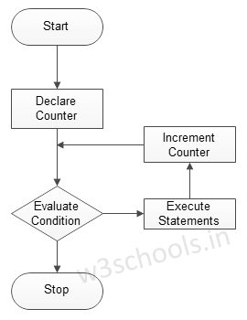

## **WHILE:**

Java while loops statement allows to repeatedly run the same block of code until a condition is met.

while loop is the most basic loop in Java. It has one control condition and executes as long the condition is true. The condition of the loop is tested before the body of the loop is executed; hence it is called an entry-controlled loop.

The basic format of while loop statement is:

Syntax:

While (condition)

{

statement(s);

Incrementation;

}

Figure - Flowchart of while loop:

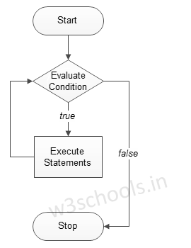

### **Example of a Java Program to Demonstrate while loop**

 Example:

public class Sample {

public static void main(String args[]) {

/\* local variable Initialization \*/ int n = 1, times = 5;

/\* while loops execution \*/

while (n <= times) {

System.out.println("Java while loops:" + n);

n++;

}

}

}

2)[do while loops](https://www.w3schools.in/java/loops/do-while/)

Java do-while loops are very similar to the while loops, but it always executes the code block at least once and furthermore as long as the condition remains true. This loop is an *exit-controlled loop*.

The basic format of do-while loop statement is:

Syntax:

do

{

statement(s);

}while( condition );

Figure - Flowchart of the do-while loop:

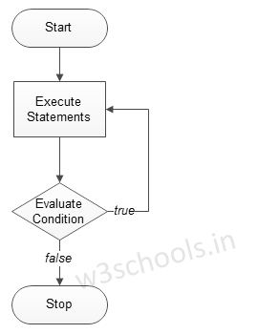

### **Example of a Java Program to Demonstrate "do while" loop**

Example:

public class Sample {

public static void main(String args[]) {

/\* local variable Initialization \*/ int n = 1, times = 0;

/\* do-while loops execution \*/ do {

System.out.println("Java do while loops:" + n);

n++;

} while (n <= times);

}

}

Program Output:

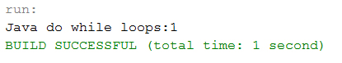

**3)FOR LOOP**

Java for loop is very similar to Java while loops in that it continues to process a block of code until a statement becomes false, and everything is defined in a single line.

The basic format of for loop statement is:

Syntax:

for ( init; condition; increment )

{

statement(s);

}

Figure - Flowchart of for loop:



### **Example of a Java Program to Demonstrate for loop**

 Example:

public class Sample {

public static void main(String args[]) {

/\* local variable Initialization \*/ int n = 1, times = 5;

/\* for loops execution \*/ for (n = 1; n <= times; n = n + 1) {

System.out.println("Java for loops:" + n);

}

}

}

Program Output:

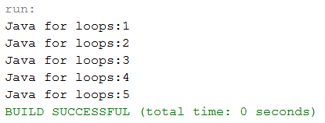

## **Java Loop Control Statements**

Loop control statements are used to change the normal sequence of execution of the loop.

|  |  |  |
| --- | --- | --- |
| Statement | Syntax | Description |
| break statement | break; | Is used to terminate loop or switch statements. |
| continue statement | continue; | Is used to suspend the execution of current loop iteration and transfer control to the loop for the next iteration. |
| goto statement | goto labelName;labelName: statement; | It transfers current program execution sequence to some other part of the program. |

# **Java Break Statement**

When a break statement is encountered inside a loop, the loop is immediately terminated and the program control resumes at the next statement following the loop.

The Java break is used to break loop or switch statement. It breaks the current flow of the program at specified condition. In case of inner loop, it breaks only inner loop.

We can use Java break statement in all types of loops such as for loop, while loop and do-while loop.

# **Java Break Statement**

When a break statement is encountered inside a loop, the loop is immediately terminated and the program control resumes at the next statement following the loop.

The Java break is used to break loop or switch statement. It breaks the current flow of the program at specified condition. In case of inner loop, it breaks only inner loop.

We can use Java break statement in all types of loops such as for loop, while loop and do-while loop.

**Syntax:**

jump-statement;

**break**;

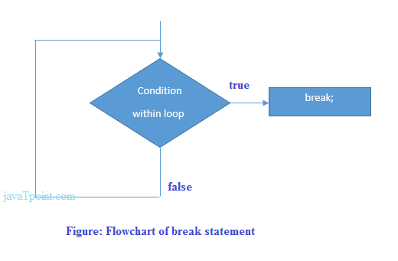

## **Java Break Statement with Loop**

**Example:**

//Java Program to demonstrate the use of break statement

//inside the for loop.

**public** **class** BreakExample {

**public** **static** **void** main(String[] args) {

    //using for loop

**for**(**int** i=1;i<=10;i++){

**if**(i==5){

            //breaking the loop

**break**;

        }

        System.out.println(i);

    }

}

}

Output:

1

2

3

4

## **Java Break Statement in while loop**

**Example:**

//Java Program to demonstrate the use of break statement

//inside the while loop.

**public** **class** BreakWhileExample {

**public** **static** **void** main(String[] args) {

    //while loop

**int** i=1;

**while**(i<=10){

**if**(i==5){

            //using break statement

            i++;

**break**;//it will break the loop

        }

        System.out.println(i);

        i++;

    }

}

}

Output:

1

2

3

4

# **Java Continue Statement**

The continue statement is used in loop control structure when you need to jump to the next iteration of the loop immediately. It can be used with for loop or while loop.

The Java continue statement is used to continue the loop. It continues the current flow of the program and skips the remaining code at the specified condition. In case of an inner loop, it continues the inner loop only.

We can use Java continue statement in all types of loops such as for loop, while loop and do-while loop.

## **Java Continue Statement Example**

**Example:**

//Java Program to demonstrate the use of continue statement

//inside the for loop.

**public** **class** ContinueExample {

**public** **static** **void** main(String[] args) {

    //for loop

**for**(**int** i=1;i<=10;i++){

**if**(i==5){

            //using continue statement

**continue**;//it will skip the rest statement

        }

        System.out.println(i);

    }

}

}

Ex:

## **Java Continue Statement in while loop**

**Example:**

//Java Program to demonstrate the use of continue statement

//inside the while loop.

**public** **class** ContinueWhileExample {

**public** **static** **void** main(String[] args) {

    //while loop

**int** i=1;

**while**(i<=10){

**if**(i==5){

            //using continue statement

            i++;

**continue**;//it will skip the rest statement

        }

        System.out.println(i);

        i++;

    }

}

}

Ex:1234678910

## **Java Arrays**

Arrays are used to store multiple values in a single variable, instead of declaring separate variables for each value.

To declare an array, define the variable type with **square brackets**:

String[] cars; or int i[]; or

int[] intArray = new int[20];

We have now declared a variable that holds an array of strings. To insert values to it, we can use an array literal - place the values in a comma-separated list, inside curly braces:

String[] cars = {"Volvo", "BMW", "Ford", "Mazda"};

int i[]={1,2,3,4};

or

int[] intArray = new int[]{ 1,2,3,4,5,6,7,8,9,10 };

## **Access the Elements of an Array**

String[] cars = {"Volvo", "BMW", "Ford", "Mazda"};  
System.out.println(cars[0]);

## **Change an Array Element**

To change the value of a specific element, refer to the index number:

### **Example**

cars[0] = "Opel";

### **Example**

String[] cars = {"Volvo", "BMW", "Ford", "Mazda"};  
cars[0] = "Opel";  
System.out.println(cars[0]);  
// Now outputs Opel instead of Volvo

## **Array Length**

To find out how many elements an array has, use the length property:

### **Example**

String[] cars = {"Volvo", "BMW", "Ford", "Mazda"};  
System.out.println(cars.length);  
// Outputs 4

## **Loop Through an Array**

You can loop through the array elements with the for loop, and use the length property to specify how many times the loop should run.

The following example outputs all elements in the **cars** array:

### **Example**

String[] cars = {"Volvo", "BMW", "Ford", "Mazda"};  
for (int i = 0; i < cars.length; i++) {  
  System.out.println(cars[i]);  
}

Example:

|  |
| --- |
| / Java program to illustrate creating an array  // of integers,  puts some values in the array,  // and prints each value to standard output.    class GFG  {      public static void main (String[] args)      {        // declares an Array of integers.        int[] arr;          // allocating memory for 5 integers.        arr = new int[5];          // initialize the first elements of the array        arr[0] = 10;          // initialize the second elements of the array        arr[1] = 20;          //so on...        arr[2] = 30;        arr[3] = 40;        arr[4] = 50;          // accessing the elements of the specified array        for (int i = 0; i < arr.length; i++)           System.out.println("Element at index " + i +                                        " : "+ arr[i]);      }  } |

Output:

Element at index 0 : 10

Element at index 1 : 20

Element at index 2 : 30

Element at index 3 : 40

Element at index 4 : 50

## **Multidimensional Arrays**

A multidimensional array is an array containing one or more arrays.

To create a two-dimensional array, add each array within its own set of **curly braces**:

### **Example**

int[][] myNumbers = { {1, 2, 3, 4}, {5, 6, 7} };

int[][][] intArray = new int[10][20][10]; //a 3D array

**myNumbers** is now an array with two arrays as its elements.

To access the elements of the **myNumbers** array, specify two indexes: one for the array, and one for the element inside that array. This example accesses the third element (2) in the second array (1) of myNumbers:

### **Example**

int[][] myNumbers = { {1, 2, 3, 4}, {5, 6, 7} };  
int x = myNumbers[1][2];  
System.out.println(x); // Outputs 7

We can also use a for loop inside another for loop to get the elements of a two-dimensional array (we still have to point to the two indexes):

### **Example**

public class MyClass {  
  public static void main(String[] args) {  
    int[][] myNumbers = { {1, 2, 3, 4}, {5, 6, 7} };  
    for (int i = 0; i < myNumbers.length; ++i) {  
      for(int j = 0; j < myNumbers[i].length; ++j) {  
        System.out.println(myNumbers[i][j]);  
      }  
    }  
  }  
}

# **Object Oriented Programming (OOPs) Concept in Java**

**Object-oriented programming:** As the name suggests, Object-Oriented Programming or OOPs refers to languages that uses objects in programming. Object-oriented programming aims to implement real-world entities like inheritance, hiding, polymorphism etc in programming. The main aim of OOP is to bind together the data and the functions that operate on them so that no other part of the code can access this data except that function.

**OOPs Concepts:**

* [Class](https://www.geeksforgeeks.org/classes-objects-java/)
* [Object](https://www.geeksforgeeks.org/classes-objects-java/)
* [Polymorphism](https://www.geeksforgeeks.org/object-oriented-programming-oops-concept-in-java/#Polymorphism)
* [Inheritence](https://www.geeksforgeeks.org/inheritance-in-java/)
* [Encapsulation](https://www.geeksforgeeks.org/encapsulation-in-java/)
* [Abstraction](https://www.geeksforgeeks.org/abstraction-in-java-2/)

Java is an object-oriented programming language.

Everything in Java is associated with classes and objects, along with its attributes and methods. For example: in real life, a car is an object. The car has **attributes**, such as weight and color, and **methods**, such as drive and brake.

Object is a realworld entity. Object orientation is methodology to design a program by using classes and objects. Object is physical entity where as class is a logical entity.

A class is a template or blue print from which type of objects are created. Object is nothing but instance of a class.

### **MyClass.java**

Create a class called "MyClass" with a variable x:

public class MyClass {  
  int x = 5;  
}

Remember from the [Java Syntax chapter](https://www.w3schools.com/java/java_syntax.asp) that a class should always start with an uppercase first letter, and that the name of the java file should match the class name.

## **Create an Object**

In Java, an object is created from a class. We have already created the class named MyClass, so now we can use this to create objects.

To create an object of MyClass, specify the class name, followed by the object name, and use the keyword new:

### **Example**

Create an object called "myObj" and print the value of x:

public class MyClass {  
  int x = 5;  
  
  public static void main(String[] args) {  
    MyClass **myObj** = new MyClass();  
    System.out.println(myObj.x);  
  }  
}

## **Multiple Objects**

You can create multiple objects of one class:

### **Example**

Create two objects of MyClass:

public class MyClass {  
  int x = 5;  
  
  public static void main(String[] args) {  
    MyClass **myObj1** = new MyClass();  // Object 1  
    MyClass **myObj2** = new MyClass();  // Object 2  
    System.out.println(myObj1.x);

myObj1.x=200;

System.out.println(myObj1.x); //it will print 200  
System.out.println(myObj2.x);  
  }  
}

**Every objects contains 3 characterstics**

1. State(represent data of an object)

2. Behavior(represent behavior of an object)

3. Identity(used to identify the objects uniquely).

PEN(object):-

State:- name raynolds,color red etc……

Behaviour:- used to write

**Declaration** :- it is representing the variable associated with object.

**Instantiation** :- The new keyword is a Java operator that creates the object.

**Initialization** :- The new operator is followed by a call to a constructor,

which initializes the the new object.

## **Using Multiple Classes**

You can also create an object of a class and access it in another class. This is often used for better organization of classes (one class has all the attributes and methods, while the other class holds the main() method (code to be executed)).

Remember that the name of the java file should match the class name. In this example, we have created two files in the same directory/folder:

* MyClass.java
* OtherClass.java

#### **MyClass.java**

public class MyClass {  
  int x = 5;  
}

#### **OtherClass.java**

class OtherClass {  
  public static void main(String[] args) {  
    MyClass **myObj** = new MyClass();  
    System.out.println(myObj.x);  
  }  
}  
When both files have been compiled:

C:\Users\Your Name>javac MyClass.java  
C:\Users\Your Name>javac OtherClass.java

Run the OtherClass.java file:

C:\Users\Your Name>java OtherClass

And the output will be:

5

Java methods

**Methods (behaviors):-**

1) Methods are used to provide the business logic of the project.

2) The methods like a functions in C-language called functions, in java language is called methods.

3) Inside the class it is possible to declare any number of methods based on the developer requirement.

4) As a software developer while writing method we have to fallow the coding standards like the method name starts with lower case letters if the method contains two words every inner word also starts uppercase letter.

5) It will improve the reusability of the code. By using methods we can optimize the code.

**Syntax:-**

**[modifiers-list] return-Type Method-name (parameter-list)throws Exception**

Ex:-

Public void m1()

Public void m2(int a,int b)

**Method Signature:-**

The name of the method and parameter list is called Method Signature. Return type and modifiers list not part of a method signature.

Ex:- m1(int a,int b)------→Method Signature

m2();------------------→Method signature

**Method declaration:-**

**Ex:-**

void m1() declaration of the method.

{

statement-1

statement-2

statement-3 implementation/body

statement-4

}

**Ex:-** Void deposit()

{ System.out.println(“money deposit logic”);

System.out.println(“congrats your money is deposited”); functionality of a method }

There are two types of methods:-

## **Access Methods With an Object**

### **Example**

Create a Car object named myCar. Call the fullThrottle() and speed() methods on the myCar object, and run the program:

// Create a Car class  
public class Car {  
   
  // Create a fullThrottle() method  
  public void ff() {  
    System.out.println("The car is going as fast as it can!");  
  }  
  
  
  // Inside main, call the methods on the myCar object  
  public static void main(String[] args) {  
    Car myCar = new Car();     // Create a myCar object  
    myCar.ff();      // Call the fullThrottle() method  
// Call the speed() method  
  }  
}  
  
// The car is going as fast as it can!

Java methods with arguments

Sending variables to methods called arguments or parameters

Public class Test

{

void m1(int i,char ch)

{

System.out.println(i+"-------"+ch);

}

void m2(float f,String str)

{

System.out.println(f+"------"+str);

}

public static void main(String[] args)

{

System.out.println("program statrs ");

Test t=new Test();

t.m1(10,'a');

t.m2(10.2f,"ratna");

}

}

## **Java Constructors**

A constructor in Java is a **special method** that is used to initialize objects. The constructor is called when an object of a class is created. It can be used to set initial values for object attributes:

### **Example**

Create a constructor:

// Create a MyClass class  
public class MyClass {  
  int x;  // Create a class attribute  
  
  // Create a **class constructor** for the MyClass class  
  MyClass() {  
    x = 5;  // Set the initial value for the class attribute x

System.out.println(“hello”);  
  }  
  
  public static void main(String[] args) {  
    MyClass myObj = new MyClass(); // Create an object of class MyClass (This will **call the constructor**)  
    System.out.println(myObj.x); // Print the value of x  
  }  
}

**Rules to declare a constructor:-**

1) Constructor name must be same as its class name.

2) Constructor doesn’t have no explicit return type if we are providing return type we are getting any compilation error and we are not getting any runtime errors just that constructor treated as normal method.

3) In the class it is possible to provide any number of constructors.

**2types of constructors:**

**1)zero argument constructors**

**user provided zero argument constructors.**

class Test

{

Test()

{

System.out.println("0-arg cons by user ");

}

public static void main(String[] args)

{

Test t=new Test();

}

}

**2) parameterized constructor**

class Test

{

Test(int i)

{

System.out.println(i);

}

void good()

{

System.out.println("good girl");

}

public static void main(String[] args)

{

Test t=new Test(10);

t.good();

}

# **Java static keyword**

The **static keyword** in Java is used for memory management mainly. We can apply java static keyword with variables, methods, blocks and nested class. The static keyword belongs to the class than an instance of the class.

The static can be:

1. Variable (also known as a class variable)
2. Method (also known as a class method)
3. Block
4. Nested class

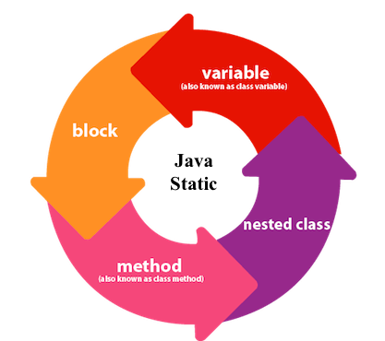

## **1) Java static variable**

If you declare any variable as static, it is known as a static variable.

* The static variable can be used to refer to the common property of all objects (which is not unique for each object), for example, the company name of employees, college name of students, etc.
* The static variable gets memory only once in the class area at the time of class loading.

### **Advantages of static variable**

It makes your program **memory efficient** (i.e., it saves memory).

#### **Understanding the problem without static variable**

**class** Student{

**int** rollno;

     String name;

     String college="ITS";

}

Suppose there are 500 students in my college, now all instance data members will get memory each time when the object is created. All students have its unique rollno and name, so instance data member is good in such case. Here, "college" refers to the common property of all objects. If we make it static, this field will get the memory only once.

#### **Java static property is shared to all objects.**

### **Program of the counter without static variable**

In this example, we have created an instance variable named count which is incremented in the constructor. Since instance variable gets the memory at the time of object creation, each object will have the copy of the instance variable. If it is incremented, it won't reflect other objects. So each object will have the value 1 in the count variable.

//Java Program to demonstrate the use of an instance variable

//which get memory each time when we create an object of the class.

**class** Counter{

**int** count=0;//will get memory each time when the instance is created

Counter(){

count++;//incrementing value

System.out.println(count);

}

**public** **static** **void** main(String args[]){

//Creating objects

Counter c1=**new** Counter();

Counter c2=**new** Counter();

Counter c3=**new** Counter();

}

}

Output:

1

1

1

### **Program of counter by static variable**

As we have mentioned above, static variable will get the memory only once, if any object changes the value of the static variable, it will retain its value.

//Java Program to illustrate the use of static variable which

//is shared with all objects.

**class** Counter2{

**static** **int** count=0;//will get memory only once and retain its value

Counter2(){

count++;//incrementing the value of static variable

System.out.println(count);

}

**public** **static** **void** main(String args[]){

//creating objects

Counter2 c1=**new** Counter2();

Counter2 c2=**new** Counter2();

Counter2 c3=**new** Counter2();

}

}

Output:

1

2

3

## **2) Java static method**

If you apply static keyword with any method, it is known as static method.

* A static method belongs to the class rather than the object of a class.
* A static method can be invoked without the need for creating an instance of a class.
* A static method can access static data member and can change the value of it.

### **Example of static method**

//Java Program to demonstrate the use of a static method.

public class MyClass {

// Static method

static void myStaticMethod() {

System.out.println("Static methods can be called without creating objects");

}

// Public method

public void myPublicMethod() {

System.out.println("Public methods must be called by creating objects");

}

// Main method

public static void main(String[] args) {

myStaticMethod(); // Call the static method

MyClass myObj = new MyClass(); // Create an object of MyClass

myObj.myPublicMethod(); // Call the public method

}

}

### **Another example of a static method that performs a normal calculation**

//Java Program to get the cube of a given number using the static method

**class** Calculate{

**static** **int** cube(**int** x){

**return** x\*x\*x;

  }

**public** **static** **void** main(String args[]){

**int** result=Calculate.cube(5);

  System.out.println(result);

  }

}

[**Test it Now**](http://www.javatpoint.com/opr/test.jsp?filename=Calculate)

Output:125

### **Restrictions for the static method**

There are two main restrictions for the static method. They are:

1. The static method can not use non static data member or call non-static method directly.
2. this and super cannot be used in static context.

**class** A{

**int** a=40;//non static

**public** **static** **void** main(String args[]){

  System.out.println(a);

 }

}

[**Test it Now**](http://www.javatpoint.com/opr/test.jsp?filename=A)

Output:Compile Time Error

### **Q) Why is the Java main method static?**

Ans) It is because the object is not required to call a static method. If it were a non-static method, JVM creates an object first then call main() method that will lead the problem of extra memory allocation.

## **3) Java static block**

* Is used to initialize the static data member.
* It is executed before the main method at the time of classloading.

### **Example of static block**

**class** A2{

**static**{System.out.println("static block is invoked");}

**public** **static** **void** main(String args[]){

   System.out.println("Hello main");

  }

}

Output:static block is invoked

Hello main

### **Q) Can we execute a program without main() method?**

Ans) No, one of the ways was the static block, but it was possible till JDK 1.6. Since JDK 1.7, it is not possible to execute a java class without the main method.

**class** A3{

**static**{

  System.out.println("static block is invoked");

  System.exit(0);

  }

}

Output:

static block is invoked

Since JDK 1.7 and above, output would be:

Error: Main method not found in class A3, please define the main method as:

public static void main(String[] args)

or a JavaFX application class must extend javafx.application.Application

# **Access Modifiers in Java**

There are two types of modifiers in Java: **access modifiers** and **non-access modifiers**.

The access modifiers in Java specifies the accessibility or scope of a field, method, constructor, or class. We can change the access level of fields, constructors, methods, and class by applying the access modifier on it.

There are four types of Java access modifiers:

1. **Private**: The access level of a private modifier is only within the class. It cannot be accessed from outside the class.
2. **Default**: The access level of a default modifier is only within the package. It cannot be accessed from outside the package. If you do not specify any access level, it will be the default.
3. **Protected**: The access level of a protected modifier is within the package and outside the package through child class. If you do not make the child class, it cannot be accessed from outside the package.
4. **Public**: The access level of a public modifier is everywhere. It can be accessed from within the class, outside the class, within the package and outside the package.

There are many non-access modifiers, such as static, abstract, synchronized, native, volatile, transient, etc. Here, we are going to learn the access modifiers only.

### **Understanding Java Access Modifiers**

Let's understand the access modifiers in Java by a simple table.

|  |  |  |  |  |
| --- | --- | --- | --- | --- |
| **Access Modifier** | **within class** | **within package** | **outside package by subclass only** | **outside package** |
| **Private** | Y | N | N | N |
| **Default** | Y | Y | N | N |
| **Protected** | Y | Y | Y | N |
| **Public** | Y | Y | Y | Y |

### **1) Public**

The **public access modifier** is accessible everywhere. It has the widest scope among all other modifiers.

**Example of public access modifier**

//save by A.java

**package** pack;

**public** **class** A{

**public** **void** msg(){System.out.println("Hello");}

}

//save by B.java

**package** mypack;

**import** pack.\*;

**class** B{

**public** **static** **void** main(String args[]){

   A obj = **new** A();

   obj.msg();

  }

}

Output:Hello

### **2) Private**

The private access modifier is accessible only within the class.

**Simple example of private access modifier**

In this example, we have created two classes A and Simple. A class contains private data member and private method. We are accessing these private members from outside the class, so there is a compile-time error.

**class** A{

**private** **int** data=40;

**private** **void** msg(){System.out.println("Hello java");}

}

**public** **class** Simple{

**public** **static** **void** main(String args[]){

   A obj=**new** A();

   System.out.println(obj.data);//Compile Time Error

   obj.msg();//Compile Time Error

   }

}

### **3) Default**

If you don't use any modifier, it is treated as **default** by default. The default modifier is accessible only within package. It cannot be accessed from outside the package. It provides more accessibility than private. But, it is more restrictive than protected, and public.

**Example of default access modifier**

In this example, we have created two packages pack and mypack. We are accessing the A class from outside its package, since A class is not public, so it cannot be accessed from outside the package.

//save by A.java

**package** pack;

**class** A{

**void** msg(){System.out.println("Hello");}

}

//save by B.java

**package** mypack;

**import** pack.\*;

**class** B{

**public** **static** **void** main(String args[]){

   A obj = **new** A();//Compile Time Error

   obj.msg();//Compile Time Error

  }

}

In the above example, the scope of class A and its method msg() is default so it cannot be accessed from outside the package.

### **4) Protected**

The **protected access modifier** is accessible within package and outside the package but through inheritance only.

The protected access modifier can be applied on the data member, method and constructor. It can't be applied on the class.

It provides more accessibility than the default modifer.

**Example of protected access modifier**

In this example, we have created the two packages pack and mypack. The A class of pack package is public, so can be accessed from outside the package. But msg method of this package is declared as protected, so it can be accessed from outside the class only through inheritance.

//save by A.java

**package** pack;

**public** **class** A{

**protected** **void** msg(){System.out.println("Hello");}

}

//save by B.java

**package** mypack;

**import** pack.\*;

**class** B **extends** A{

**public** **static** **void** main(String args[]){

   B obj = **new** B();

   obj.msg();

  }

}

Output:Hello

3) **Inheritance in Java**

**Inheritance in Java** is a mechanism in which one object acquires all the properties and behaviors of a parent object. It is an important part of OOPs (Object Oriented programming system).

The idea behind inheritance in Java is that you can create new classes that are built upon existing classes. When you inherit from an existing class, you can reuse methods and fields of the parent class. Moreover, you can add new methods and fields in your current class also.

Inheritance represents the **IS-A relationship** which is also known as a parent-child relationship.

### **Why use inheritance in java**

* For Method Overriding (so runtime polymorphism can be achieved).
* For Code Reusability.

### **Terms used in Inheritance**

* **Class:** A class is a group of objects which have common properties. It is a template or blueprint from which objects are created.
* **Sub Class/Child Class:** Subclass is a class which inherits the other class. It is also called a derived class, extended class, or child class.
* **Super Class/Parent Class:** Superclass is the class from where a subclass inherits the features. It is also called a base class or a parent class.
* **Reusability:** As the name specifies, reusability is a mechanism which facilitates you to reuse the fields and methods of the existing class when you create a new class. You can use the same fields and methods already defined in the previous class.

### **The syntax of Java Inheritance**

1. **class** Subclass-name **extends** Superclass-name
2. {
3. //methods and fields
4. }

The **extends keyword** indicates that you are making a new class that derives from an existing class. The meaning of "extends" is to increase the functionality.

In the terminology of Java, a class which is inherited is called a parent or superclass, and the new class is called child or subclass.

## **Types of inheritance in java**

On the basis of class, there can be three types of inheritance in java: single, multilevel and hierarchical.

In java programming, multiple and hybrid inheritance is supported through interface only. We will learn about interfaces later.

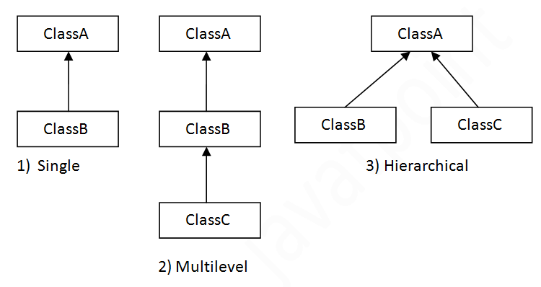

When one class inherits multiple classes, it is known as multiple inheritance. For Example:

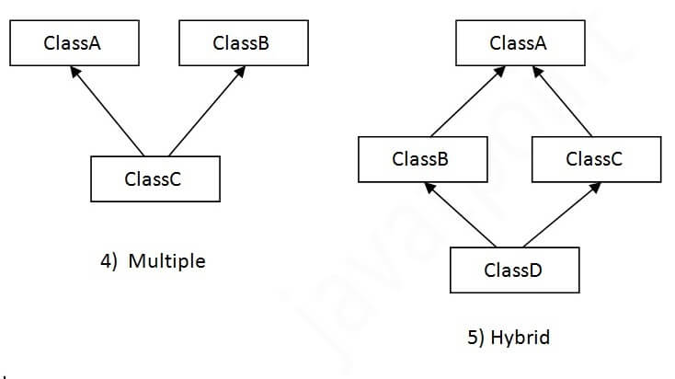

## **Single Inheritance Example**

*File: TestInheritance.java*

**class** Animal{

**void** eat(){System.out.println("eating...");}

}

**class** Dog **extends** Animal{

**void** bark(){System.out.println("barking...");}

}

**class** TestInheritance{

**public** **static** **void** main(String args[]){

Dog d=**new** Dog();

d.bark();

d.eat();

}}

Output:

barking...

eating...

## **Multilevel Inheritance Example**

*File: TestInheritance2.java*

**class** Animal{

**void** eat(){System.out.println("eating...");}

}

**class** Dog **extends** Animal{

**void** bark(){System.out.println("barking...");}

}

**class** BabyDog **extends** Dog{

**void** weep(){System.out.println("weeping...");}

}

**class** TestInheritance2{

**public** **static** **void** main(String args[]){

BabyDog d=**new** BabyDog();

d.weep();

d.bark();

d.eat();

}}

Output:

weeping...

barking...

eating...

## **Hierarchical Inheritance Example**

*File: TestInheritance3.java*

**class** Animal{

**void** eat(){System.out.println("eating...");}

}

**class** Dog **extends** Animal{

**void** bark(){System.out.println("barking...");}

}

**class** Cat **extends** Animal{

**void** meow(){System.out.println("meowing...");}

}

**class** TestInheritance3{

**public** **static** **void** main(String args[]){

Cat c=**new** Cat();

c.meow();

c.eat();

//c.bark();//C.T.Error

}}

Output:

meowing...

eating...

# **4. Multiple Inheritance**

GrandParent

/ \

/ \

Parent1 Parent2

\ /

\ /

Test

Multiple Inheritance is a feature of object oriented concept, where a class can inherit properties of more than one parent class. The problem occurs when there exist methods with same signature in both the super classes and subclass. On calling the method, the compiler cannot determine which class method to be called and even on calling which class method gets the priority.

**Why Java doesn’t support Multiple Inheritance?**

Consider the below Java code. It shows error.

|  |
| --- |
| // First Parent class  class Parent1  {      void fun()      {          System.out.println("Parent1");      }  }    // Second Parent Class  class Parent2  {      void fun()      {          System.out.println("Parent2");      }  }    // Error : Test is inheriting from multiple  // classes  class Test extends Parent1, Parent2  {     public static void main(String args[])     {         Test t = new Test();         t.fun();     }  } |

Output :

Compiler Error

From the code, we see that, on calling the method fun() using Test object will cause complications such as whether to call Parent1’s fun() or Parent2’s fun() method.

**Hybrid Inheritance(Through Interfaces) :**It is a mix of two or more of the above types of inheritance. Since java doesn’t support multiple inheritance with classes, the hybrid inheritance is also not possible with classes. In java, we can achieve hybrid inheritance only through [Interfaces](http://quiz.geeksforgeeks.org/interfaces-in-java/).

[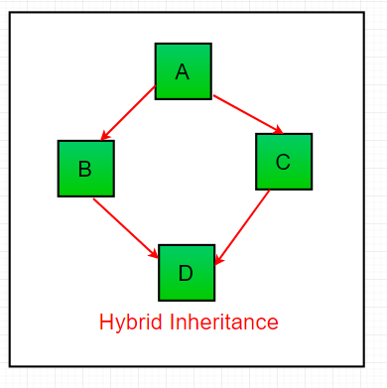](https://cdncontribute.geeksforgeeks.org/wp-content/uploads/inheritance-1.png)

# **Encapsulation in Java**

Encapsulation is defined as the wrapping up of data under a single unit. It is the mechanism that binds together code and the data it manipulates.Other way to think about encapsulation is, it is a protective shield that prevents the data from being accessed by the code outside this shield.

* Technically in encapsulation, the variables or data of a class is hidden from any other class and can be accessed only through any member function of own class in which they are declared.
* As in encapsulation, the data in a class is hidden from other classes, so it is also known as **data-hiding**.
* Encapsulation can be achieved by: Declaring all the variables in the class as private and writing public methods in the class to set and get the values of variables.

[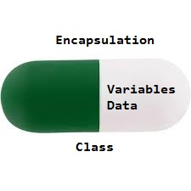](http://cdncontribute.geeksforgeeks.org/wp-content/uploads/Encapsulation.jpg)

|  |
| --- |
| // Java program to demonstrate encapsulation  public class Encapsulate  {  // private variables declared  // these can only be accessed by  // public methods of class  private String geekName;  private int geekAge;  // set method for age to access  // private variable geekage  public void setAge( int newAge)  {  geekAge = newAge;  }  // get method for age to access  // private variable geekAge  public int getAge()  {  return geekAge;  }        // set method for name to access  // private variable geekName  public void setName(String newName)  {  geekName = newName;  } |

In the above program the class EncapsulateDemo is encapsulated as the variables are declared as private. The get methods like getAge() , getName() , getRoll() are set as public, these methods are used to access these variables. The setter methods like setName(), setAge(), setRoll() are also declared as public and are used to set the values of the variables.

The program to access variables of the class Encapsulate Demo is shown below:

|  |
| --- |
| public class TestEncapsulation  {      public static void main (String[] args)      {          Encapsulate obj = new Encapsulate();            // setting values of the variables          obj.setName("Harsh");          obj.setAge(19);          obj.setRoll(51);            // Displaying values of the variables          System.out.println("Geek's name: " + obj.getName());          System.out.println("Geek's age: " + obj.getAge());              } |

Output:

Geek's name: Harsh

Geek's age: 19

**Advantages of Encapsulation**:

* **Data Hiding:** The user will have no idea about the inner implementation of the class. It will not be visible to the user that how the class is storing values in the variables. He only knows that we are passing the values to a setter method and variables are getting initialized with that value.
* **Increased Flexibility:** We can make the variables of the class as read-only or write-only depending on our requirement. If we wish to make the variables as read-only then we have to omit the setter methods like setName(), setAge() etc. from the above program or if we wish to make the variables as write-only then we have to omit the get methods like getName(), getAge() etc. from the above program
* **Reusability:** Encapsulation also improves the re-usability and easy to change with new requirements.
* **Testing code is easy:** Encapsulated code is easy to test for unit testing.

**5)JAVA ABSTRACTION**

Data **abstraction** is the process of hiding certain details and showing only essential information to the user.  
Abstraction can be achieved with either **abstract classes** or **interfaces** (which you will learn more about in the next chapter).

The abstract keyword is a non-access modifier, used for classes and methods:

* **Abstract class:** is a restricted class that cannot be used to create objects (to access it, it must be inherited from another class).
* **Abstract method:** can only be used in an abstract class, and it does not have a body. The body is provided by the subclass (inherited from).

An abstract class can have both abstract and regular methods:

**abstract** class Animal {  
  public **abstract** void animalSound();  
  public void sleep() {  
    System.out.println("Zzz");  
  }  
}

From the example above, it is not possible to create an object of the Animal class:

Animal myObj = new Animal(); // will generate an error

To access the abstract class, it must be inherited from another class. Let's convert the Animal class we used in the [Polymorphism](https://www.w3schools.com/java/java_polymorphism.asp) chapter to an abstract class:

Remember from the [Inheritance chapter](https://www.w3schools.com/java/java_inheritance.asp) that we use the extends keyword to inherit from a class.

### **Example**

// Abstract class  
**abstract** class Animal {  
  // Abstract method (does not have a body)  
  public **abstract** void animalSound();  
  // Regular method  
  public void sleep() {  
    System.out.println("Zzz");  
  }  
}  
  
// Subclass (inherit from Animal)  
class Pig extends Animal {  
  public void animalSound() {  
    // The body of animalSound() is provided here  
    System.out.println("The pig says: wee wee");  
  }  
}  
  
class MyMainClass {  
  public static void main(String[] args) {  
    Pig myPig = new Pig(); // Create a Pig object  
    myPig.animalSound();  
    myPig.sleep();  
  }  
}

## 6) **Java Polymorphism**

Polymorphism means "many forms", and it occurs when we have many classes that are related to each other by inheritance.

Like we specified in the previous chapter; [**Inheritance**](https://www.w3schools.com/java/java_inheritance.asp) lets us inherit attributes and methods from another class. **Polymorphism** uses those methods to perform different tasks. This allows us to perform a single action in different ways.

For example, think of a superclass called Animal that has a method called animalSound(). Subclasses of Animals could be Pigs, Cats, Dogs, Birds - And they also have their own implementation of an animal sound (the pig oinks, and the cat meows, etc.):

class Animal {  
  public void animalSound() {  
    System.out.println("The animal makes a sound");  
  }  
}  
  
class Pig extends Animal {  
  public void animalSound() {  
    System.out.println("The pig says: wee wee");  
  }  
}  
  
class Dog extends Animal {  
  public void animalSound() {  
    System.out.println("The dog says: bow wow");  
  }  
}  
  
class MyMainClass {  
  public static void main(String[] args) {  
    Animal myAnimal = new Animal();  // Create a Animal object  
    Animal myPig = new Pig();  // Create a Pig object  
    Animal myDog = new Dog();  // Create a Dog object  
  
    myAnimal.animalSound();  
    myPig.animalSound();  
    myDog.animalSound();  
  }  
}

**polymorphism can achieve following two ways**

**1)method overloading**

**2)method overriding**

# **Method Overloading in Java**

If a class has multiple methods having same name but different in parameters, it is known as **Method Overloading**.

If we have to perform only one operation, having same name of the methods increases the readability of the program.

Suppose you have to perform addition of the given numbers but there can be any number of arguments, if you write the method such as a(int,int) for two parameters, and b(int,int,int) for three parameters then it may be difficult for you as well as other programmers to understand the behavior of the method because its name differs.

So, we perform method overloading to figure out the program quickly.

## **Advantage of method overloading**

Method overloading increases the readability of the program.

### **Different ways to overload the method**

There are two ways to overload the method in java

1. By changing number of arguments
2. By changing the data type

### **1) Method Overloading: changing no. of arguments**

In this example, we have created two methods, first add() method performs addition of two numbers and second add method performs addition of three numbers.

In this example, we are creating static methods so that we don't need to create instance for calling methods.

**class** Adder{

**static** **int** add(**int** a,**int** b){**return** a+b;}

**static** **int** add(**int** a,**int** b,**int** c){**return** a+b+c;}

}

**class** TestOverloading1{

**public** **static** **void** main(String[] args){

System.out.println(Adder.add(11,11));

System.out.println(Adder.add(11,11,11));

}}

output:

22

33

### **2) Method Overloading: changing data type of arguments**

In this example, we have created two methods that differs in data type. The first add method receives two integer arguments and second add method receives two double arguments.

**class** Adder{

**static** **int** add(**int** a, **int** b){**return** a+b;}

**static** **double** add(**double** a, **double** b){**return** a+b;}

}

**class** TestOverloading2{

**public** **static** **void** main(String[] args){

System.out.println(Adder.add(11,11));

System.out.println(Adder.add(12.3,12.6));

}}

# **2) Method Overriding in Java**

If subclass (child class) has the same method as declared in the parent class, it is known as **method overriding in Java**.

In other words, If a subclass provides the specific implementation of the method that has been declared by one of its parent class, it is known as method overriding.

### **Usage of Java Method Overriding**

* Method overriding is used to provide the specific implementation of a method which is already provided by its superclass.
* Method overriding is used for runtime polymorphism

#### **Rules for Java Method Overriding**

1. The method must have the same name as in the parent class
2. The method must have the same parameter as in the parent class.
3. There must be an IS-A relationship (inheritance).

### **Example of method overriding**

In this example, we have defined the run method in the subclass as defined in the parent class but it has some specific implementation. The name and parameter of the method are the same, and there is IS-A relationship between the classes, so there is method overriding.

1. //Java Program to illustrate the use of Java Method Overriding
2. //Creating a parent class.

**class** Vehicle{

  //defining a method

**void** run(){System.out.println("Vehicle is running");}

}

//Creating a child class

**class** Bike2 **extends** Vehicle{

  //defining the same method as in the parent class

**void** run(){System.out.println("Bike is running safely");}

**public** **static** **void** main(String args[]){

  Bike2 obj = **new** Bike2();//creating object

  obj.run();//calling method

  }

}

[**Test it Now**](http://www.javatpoint.com/opr/test.jsp?filename=Bike2)

Output:

Bike is running safely

Sample questions

1)write difference between c,c++ and java?

2)explain java features?

3)explain about java variables, different types of data types and it’s allocated memory sizes, default values?

4) what is type casting and it’s types with example programs?

5) explain arithmetic operators with example programs?

6)explain about unary operators with example programs?

7)explain assignment and relational operators with example programs?

8)explain logical operators with example programs?

9)explain about java string class and it’s methods with example programs?

10)write java control statements with example programs?

11)explains conditional operators with example programs?

12)write different types of loop statements with example programs ?

13)explain about loop control statements with example programs?

14)define array with syntax? explain different types of arrays with example programs?

15)explain about oop’s concept with example programs?

16)explain about constructor and it’s types with example programs?

17)explain about static keyword,static method,static block with example programs?

18)explain about java access modifiers with example programs?

19)explain about method overloading and overriding with example programs?